High survival exemption for plaice caught by TR2 vessels using Trammel Nets in ICES areas VIIf and VIIg

Request under Article 15.4(b) of Regulation (EU) 1380/2013 to exempt from the landing obligation plaice caught by trammel nets in ICES areas VIIf and VIIg.

Summary
Article 15.4(b) of Regulation (EU) 1380/2013 on the Common Fisheries Policy states that the landing obligation shall not apply to:
“species for which scientific evidence demonstrates high survival rates, taking into account the characteristics of the gear, of the fishing practises and of the ecosystem;”
In response to industry’s view that Plaice has a high rate of survival, the Centre for Environment, Fisheries and Aquaculture Science (Cefas) was commissioned to carry out a number studies on high survivability of Plaice. The sea trials were carried out in Swansea Bay off the coast of South Wales on a vessel representative of normal fishing activity targeting Dover sole using trammel nets.
The North Western Waters regional group notes that scientific evidence demonstrates a survivability rate of 49% for plaice (Pleuronectes platessa) caught by TR2 vessels using trammel nets in area VIIf and recommends that catches of Plaice caught in areas VIIf and g should be exempt from the landing obligation on grounds of high survival rates, as provided for by Article 15.4(b) Regulation (EU) 1380/2013. This will reduce the risk of vessels being prevented from continuing to fish at sea due to their low Plaice quota.

Key Information
Exemption target: Plaice (Pleuronectes platessa)
Exemption grounds: High survivability.
Survivability rates: 49%
Vessels affected: 7 (UK)
Discard rate: 73%
2018 UK TAC: 77

Fishery
In 2017, 7 vessels registered in the UK caught plaice with Trammel Nets in area VIIf and VIIg, landing 0.18 tonnes. These vessels catch and land multiple quota and non-quota stocks across area VI. The quota stocks that were landed by these 7 vessels in 2017 included, Anglers, Cod, Haddock, Skates 7 Rays, Saithe, Pollack, Hake and Sole. The vessels landed a total of 41.6 tonnes of quota stocks in 2017.
Figure 1 below illustrates the mean number of fishing trips and mean number of trips sampled for trammel and gill netters between 20134 and 2016. The illustration shows that the fishing effort from UK trammel nets in area VIIf and VIIg is low.

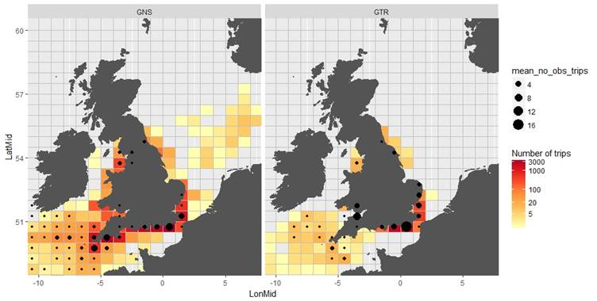
Figure 1. Mean number of fishing trips (coloured rectangles) and mean number of trips sampled (back circles) for the netters métiers, between the years 2013 and 2016, for trammel nets (GTR) and gill nets (GNS).

The discard rate for plaice in area VIIf and VIIg is 73%. An estimated 22.86 tonnes will be discarded in 2018. The survival rate in the study is a minimum of 49%, which would indicate that at least 11.2 tonnes of the discarded Plaice will survive. The survival rate is discussed further below

Study
Sea trials were carried out in Swansea Bay (ICES rectangle 31E6), off the coast off South Wales (see Figure 2) on a vessel which is a fibre-gall hulled netter of 9.88m overall length with a 90kw engine. In total 44 hauls were made during two neap tides (see Figure 2 for locations of hauls). The fishing activity of the vessel was representative of normal practice. All fishing was carried out during neap tides on typical fishing grounds. Sole was the main target species.
Figure 2. Map of Swansea Bay and the locations of the hauls observed in the study.
Fishing activity at sea
At sea sole trammel nets were shot from a net pound, hauled with a hydraulic hauler and cleared as per normal commercial fishing practice; the nets were boarded on deck and were cleared once the final anchor was retrieved and stowed. Sole and plaice were handed to the observer at the time that these fish would normally have been retained in a fish box or discarded back to the sea.
Data collection
All sole and plaice caught were recorded by length. The catch composition from each tier was recorded separately, alongside the positional and environmental information specific of that tier. Each individual fish was measured and scored using a predefined assessment protocol developed methods described in the ICES WKMEDS 2014 report and refined in the Cefas laboratory using aquarium kept plaice. Vitality was assess using a semi-quantitative assessment of activity and a quantitative reflex and injury scoring method.

Catch composition
The catch composition was dominated by starry smooth hound, with sole and plaice featuring as the next most abundant species. All sole and plaice caught were recorded. The length distribution is shown in Figure 3. A total of 409 plaice and 455 sole were caught and assessed for vitality. In total, 83 plaice and 189 sole were assessed as being dead/moribund at the point that they were unmeshed from the nets. The remaining fish were scored and a proportion of fish was selected for the on-board observation tanks. Table 1 sets out the vitality assessment and survivability probability of Plaice from the hauls used in the study.

Table 1: Survivability and catch profile of study by vitality assessment for plaice.
Vitality assessment | Proportion of fish at each vitality in study 1 | Survivability probability (%) | Proportion of fish at each vitality in study 2 | Survivability probability (%)
Excellent | 0.53 | 72.7 | 0.39 | 50.0
Good | 0.10 | 36.4 | 0.10 | 0.0
Poor | 0.16 | 42.1 | 0.15 | 6.3
Dead | 0.20 | - | 0.46 | -

Figure 3. Length frequencies of plaice and sole in trammel net catches and held for observation

Results
The estimated survival in the observation period was 49.3% (37.1-59.8%)
The study identified a number of potential stressors on the captive fish associated with the methodology in this study, which are likely to have resulted in experimental induced mortality and therefore underestimated survival. Specifically these stressors included:

- Handling fish to conduct the vitality assessments, length measurements and to put fish into the on-board tanks
- Captivity in the on-board tanks (movement caused by vessel movement; proximity with other fish; serial flow of water from top to bottom tank)
- Stopping water flow to on-board tanks on approach to port until docked (reducing dO2)
- Transfer of fish into tubs (handling of fish)
- Carrying tubs off the vessel and transporting, by van, to onshore holding tanks (increased temperature, reduced dO2, movement)
- Handling the fish to transfer into onshore tanks
- Adjusting to salinity and temperature

Constructing survival studies on small commercial vessels in remote ports is technical and logistical challenging. Due to restricted deck space the vessels could only hold small number of fish in suitable tanks, and these must be transferred to shore when fishing for less than one day, this meant that the use of controls had to be limited and there were unavoidable additional stressors exerted on the fish. The survival estimates should, therefore, be interpreted as minimum discard survival estimates.

Conclusion
The UK believes that the fishing practices in Swansea Bay resulting in survival rates of 49% for bycatches of Plaice are representative of general fishing practices by the vessels fishing for sole using trammel nets in ICES areas VIIf & g. The effort of UK vessels in this area is low as illustrated in Figure 1, and the estimated discards from the vessels using trammel nets is 22.86 tonnes. This high survival exemption will be limited to a very small number of vessels and will only apply to a small proportion of their fishing activity. However this high survival exemption will be vital for these vessels to be allowed to continue to target valuable quota and non-quota stocks through the year.

On this basis we would like to request a high survival exemption for plaice caught by trammel nets in ICES Areas VIIf & g.

Table 5: Completed STECF table for high survivability proposal
Country | Exemption applied for (species, area, gear type) | Species as bycatch or target | Number of vessels subject to the landing obligation | Landings (by landing obligation subject vessels) | Estimated Discards | Estimated Catch | Discard Rate | Estimated discard survival rate from provided studies
UK | Plaice  VIIf, g  Trammel nets | Bycatch | 7 | 0.18t | No discard data  (22.86t based on area discard rate) | 23.02t | No discard data  (73% for stock in VIIf, g) | 49%

